Git and GitHub tasks -1
To install git
Yum install git
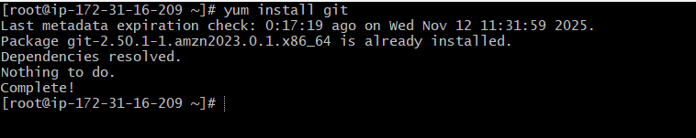
To initialize git
Initialized empty git in repository c
To create new file
Touch a b c d e f g
To see status
We need to use git status
We can see list of files which are not tracked yet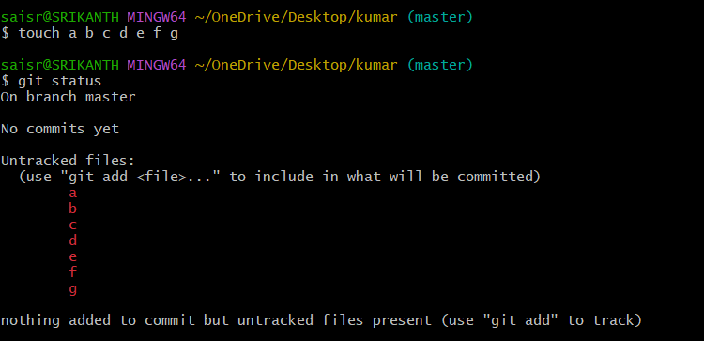

To move from untracked area to tracked area
We need to use command git add filename
For example, I need to move a
git add a
now a has been moved to tracked
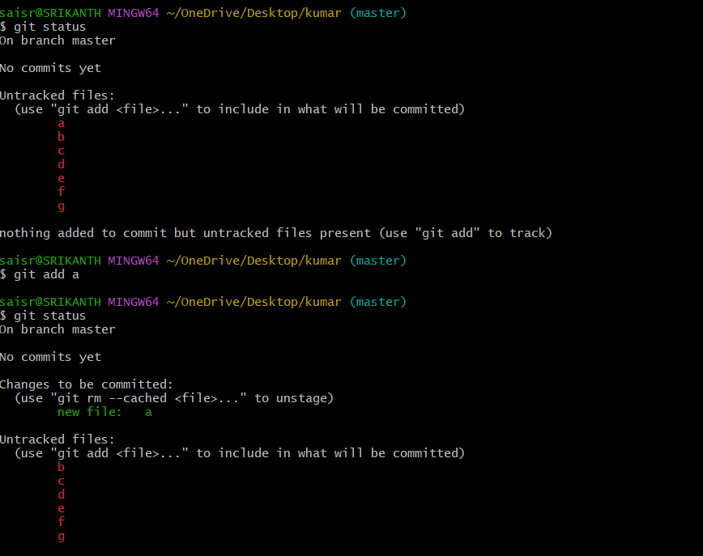

To move all the files from untracked to tracked
We need to use git add .
Now we can see all the files from b to g has been moved to tracked
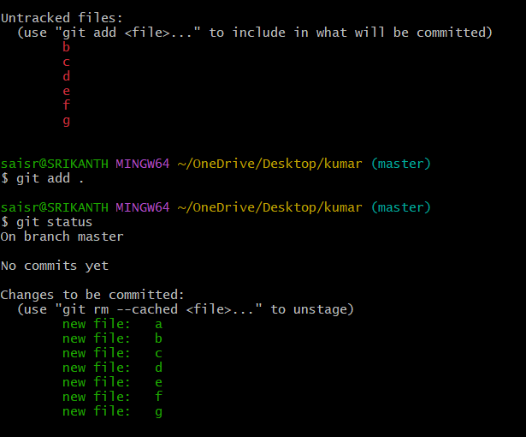
To configure user name and email
First we need to give git config—list
we need to use command git config –global user.name=”Sai Prashanth”
now to check git config –list
email- git config –global user.email=saip59921@gmail.com
git config –list
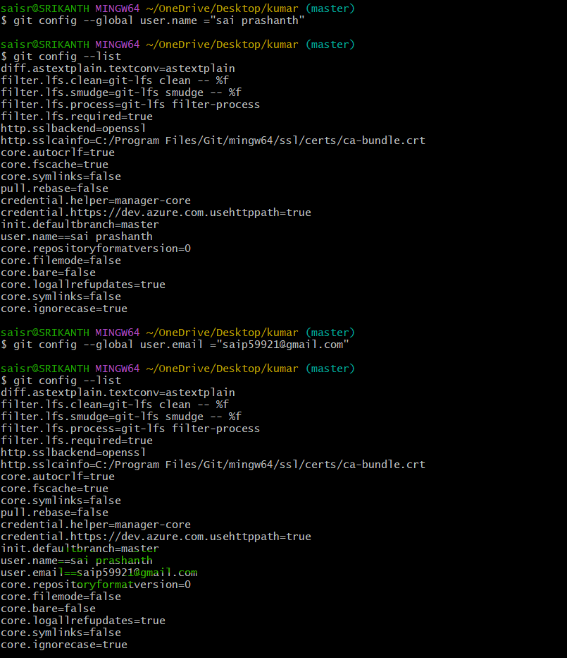
To commit the changes in your local machine
git commit =m “message” origin
it will commit all your changes
what ever changes have been made everything has been committed

1d43b88- commit id
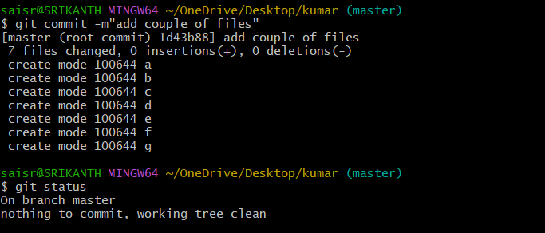
To remember the commit id
We need to use git log command
We will always use 4 or 5 digits
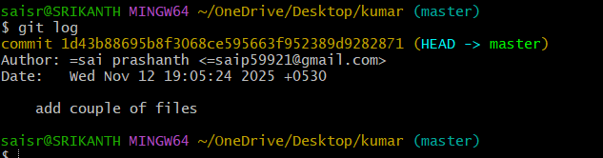
To move all the changes to central repository
We need to create account in github
We need to create a repository
git remote add origin paste the link from repository
Then git remote -v
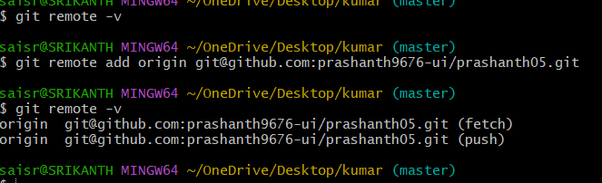
Now try git push -u origin master
It means it will get understand to move files to which branch
Once you entered you will get the authentication error
We need to use ssh-keygen for getting one default keypair
Path
ssh-keygen
enter 3 times
copy the keypair address
cat and paste it
copy the entire key now and got to git hub-settings-ssh and gpg keys-click on new ssh key-add title and add key -click on add ssh key
try to push now using git push -u origin master and now go to github-open your repository and do refresh
finally the files has been moved
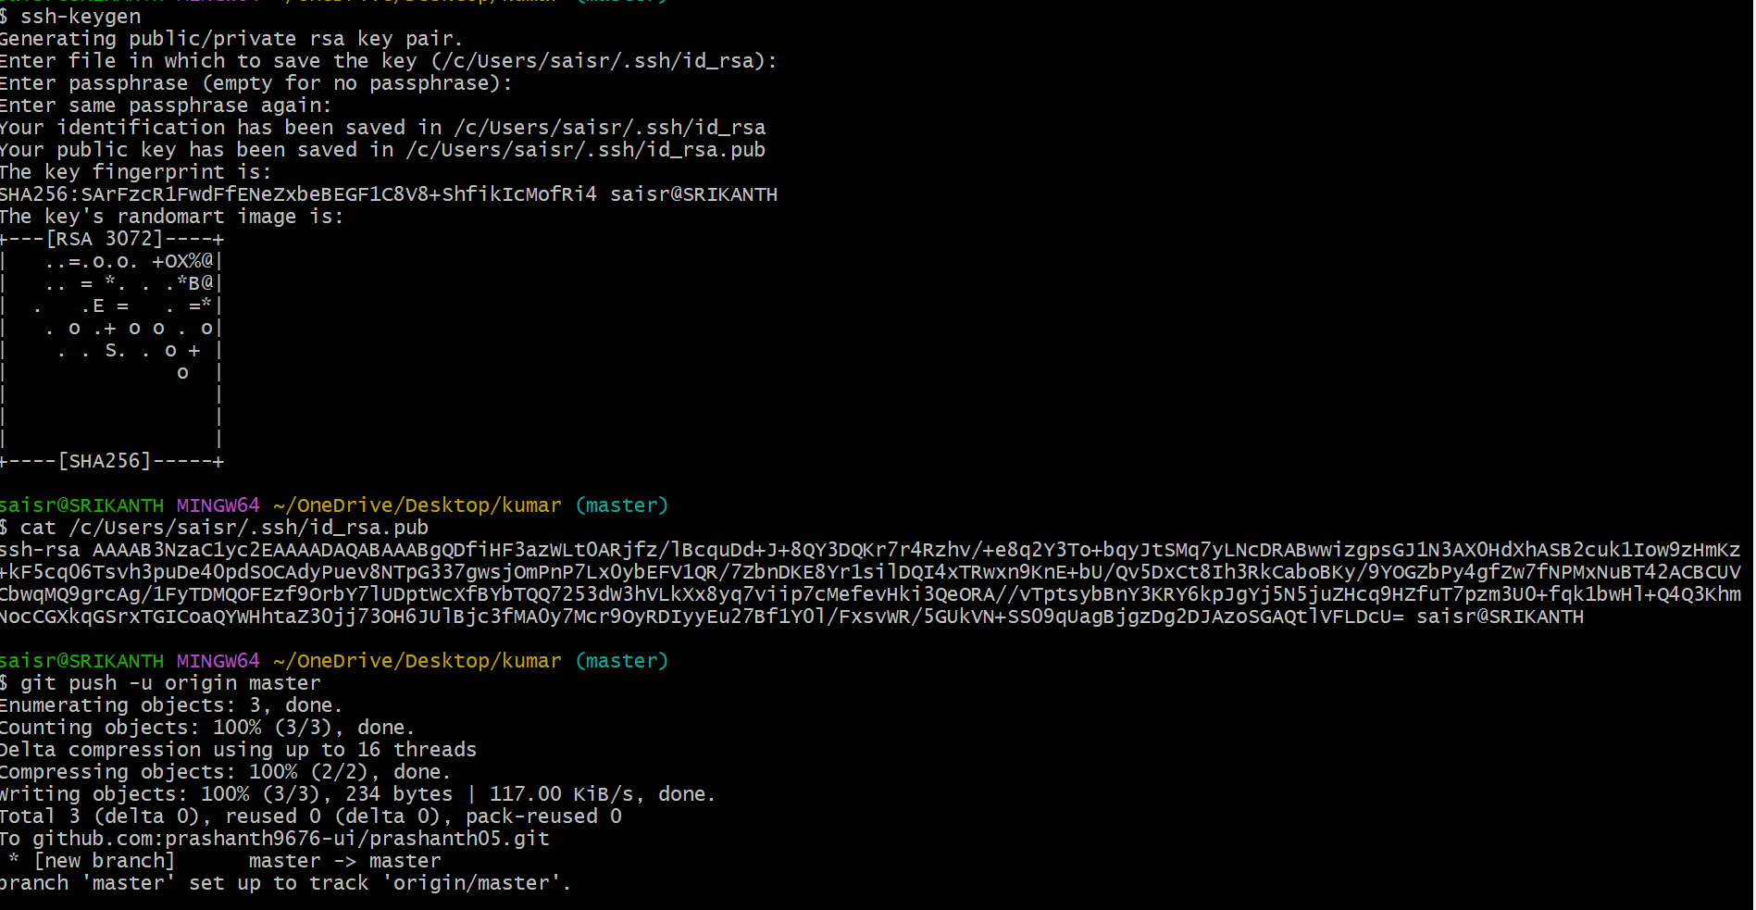
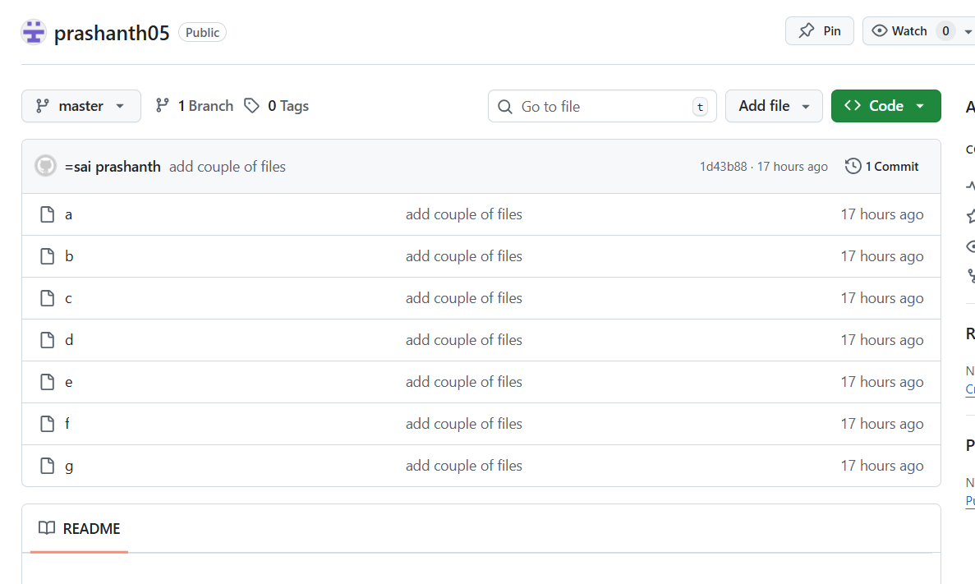

To delete any file
rm filename
now to check use command git status
to add and commit
git add.
To check whether file has been deleted in repository or not
git commit -m “deleted filename
git push -u origin master
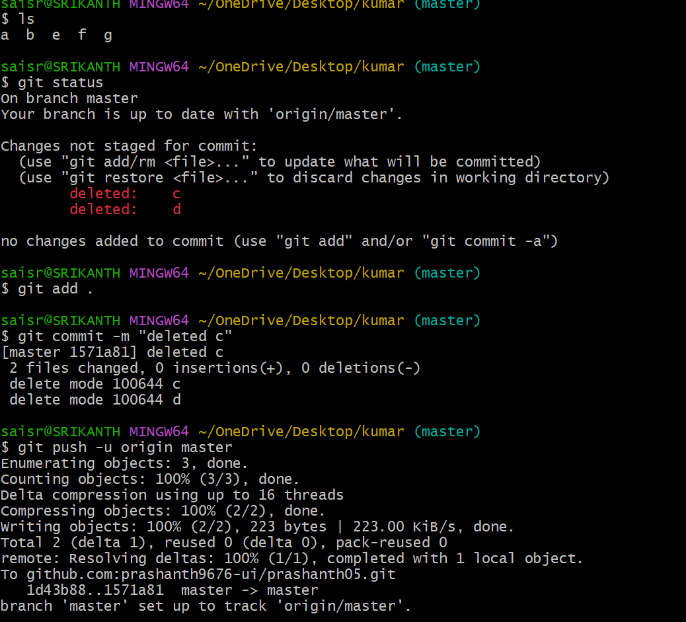
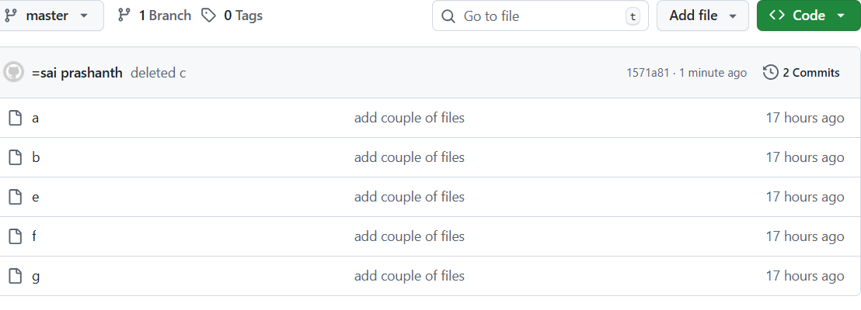
To make changes from central repository to local machine
We need to use git pull command
If you create a new file directly in central repository, to view that in local machine use git pull
git pull
ls
you can see new file has been added
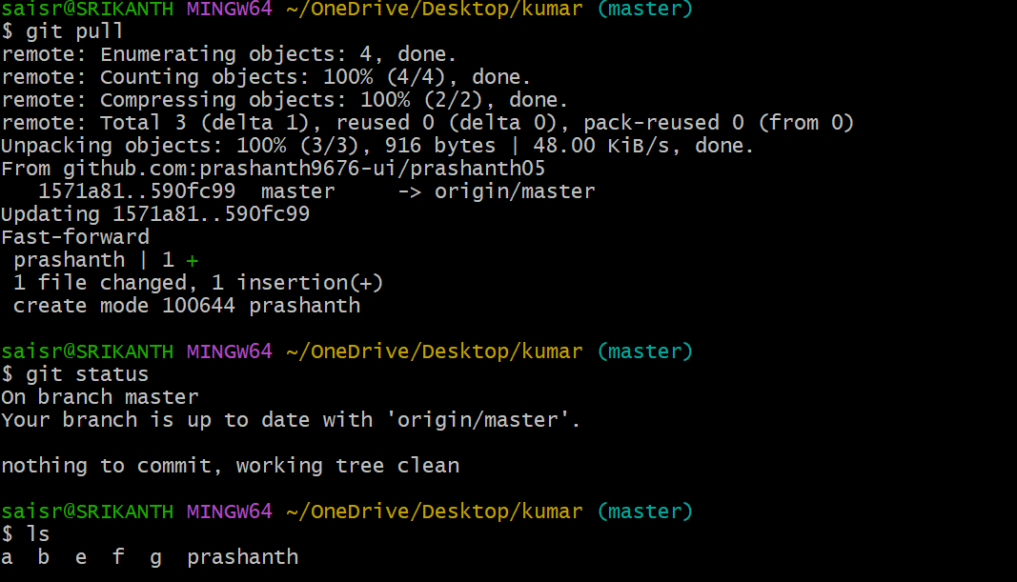
We have types of commands to make changes from central repository to local machine
git pull, git clone and git fetch
git clone is used to download source code or complete reposotory from central repository to local machine
git clone addyour sshlink and enter
ls
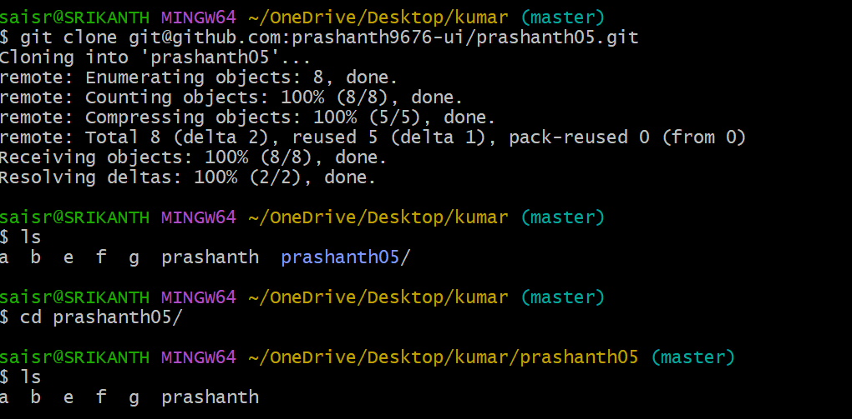
Git revert
With the help of git revert we can revert the changes
We use command git revert <commid_id>
First to see the log files or deleted files we need to use git log -4. -4 describes top 4 logs
git log -4
git revert enter first 4 or 5 digits of your commit id
git reset
if we want to move from untracked to tracked
we need to use git reset
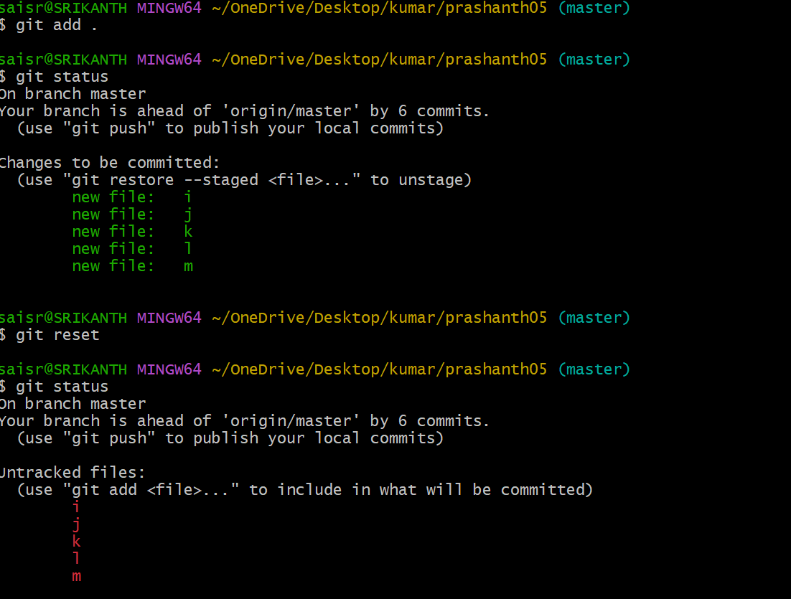
Set up MFA authentication
Install MS authenticator app in mobile
Now go to your GitHub account
Go to settings-password and authentication-two factor methods
Scan with your QR code and enable the access through the mobile
